Quan | Title | Brand | Type | Description | Photo
1 | immobilizer for babies | PIGG-O- STATT |  | brand: PIGG-O-STATT; description: mobile; shopping cart dim. approx. 560x510x860 mm; incl. various belongings; | 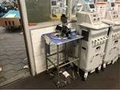
1 | surgical dispenser |  |  |  | 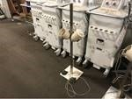
1 | anesthesia machine | MDS Matrx | VMC  Quantiflex | brand: MDS Matrx; type: VMC Quantiflex; description: on mobile standard; | 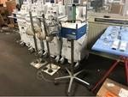
5 | haemostatic forceps |  |  |  | 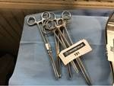
4 | saddle hooks | V.Mueller | NL1011 | brand: V.Mueller; type: NL1011; | 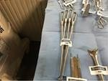
3 | haemostatic forceps |  |  |  | 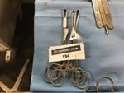
2 | hemostatic forceps | Princeton |  | brand: Princeton; | 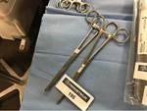

2 | retractors | Sklar |  | brand: Sklar; | 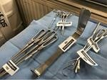
1 | retractor | Reed & Barton |  | brand: Reed & Barton; | 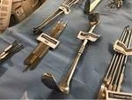
1 | trachael hook | Integra | Miltex | brand: Integra; type:  Miltex; description: 6-1 / 2 ”; | 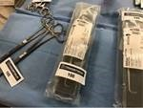
1 | trachael hook | Integra | Miltex | brand: Integra; type:  Miltex; description: 6-1 / 2 ”;
3 | retractors | Miltex |  | brand: Miltex;
5 | bone curettes |  |  |  | 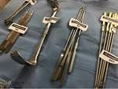
4 | bone curettes | Princeton |  | brand: Princeton; | 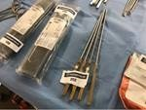
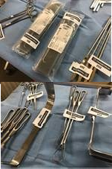

5 | bone curettes | Princeton |  | brand: Princeton; | 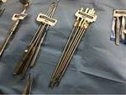
1 | retractor | Carstens |  | brand: Carstens; | 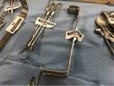
1 | lot of tea spoons |  |  |  | 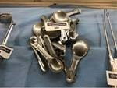
3 | pliers | Weller |  | brand: Weller; | 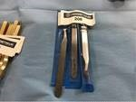
1 | small tear grater | Stryker |  | brand: Stryker; | 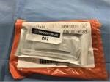
9 | skin temperature probe | Measuremen t |  | brand: Measurement; | 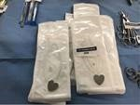
2 | bone curettes | Princeton |  | brand: Princeton; | 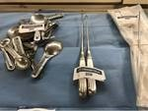

4 | transfixing pins | Stryker |  | brand: Stryker; description: Ø 4/5 mm; | 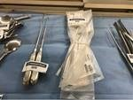
5 | bone curettes |  |  |  | 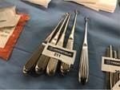
5 | hemostatic forceps |  |  |  | 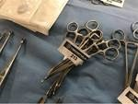
4 | surgical tools |  |  |  | 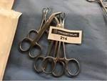
5 | pliers |  |  |  | 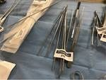
5 | pliers |  |  |  | 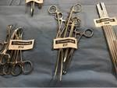
4 | hemostatic forceps

3 | haemostatic forceps |  |  |  | 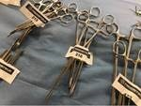
4 | hemostatic forceps |  |  |  | 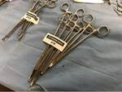
5 | double drill sleeves |  |  | brand: Swiss / Synthes; | 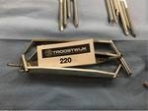
5 | double drill sleeves |  |  | brand: Swiss / Synthes; | 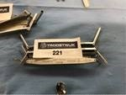
5 | double drill sleeves |  |  | brand: Swiss / Synthes; | 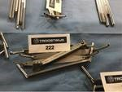
5 | double drill sleeves |  |  | brand: Swiss / Synthes; | 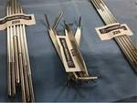
5 | schanz screws | Swiss / Synthes |  | brand: Swiss / Synthes; | 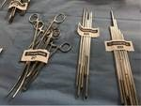

6 | schanz screws | Swiss / Synthes |  | brand: Swiss / Synthes; | 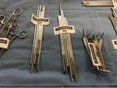
5 | schanz screws | Swiss / Synthes |  | brand: Swiss / Synthes; | 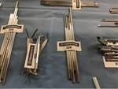
5 | schanz screws | Swiss / Synthes |  | brand: Swiss / Synthes; | 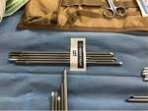
5 | schanz screws | Swiss / Synthes |  | brand: Swiss / Synthes; | 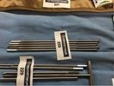
5 | schanz screws | Swiss / Synthes |  | brand: Swiss / Synthes; | 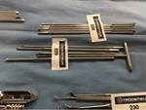
7 | surgical tools |  |  |  | 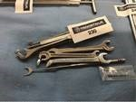
4 | surgical tools |  |  |  | 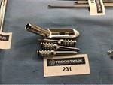

1 | lot of distal radius plates | Swiss / Synthes |  | brand: Swiss / Synthes; | 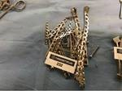
5 | double drill sleeves |  |  | brand: Swiss / Synthes; | 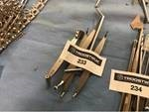
6 | screws and drills |  |  |  | 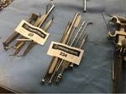
1 | lots of screws and drilling |  |  |  | 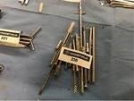
1 | surgical set |  |  |  | 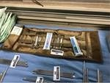
1 | many clips |  |  |  | 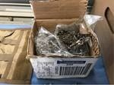
5 | schanz screws | Swiss / Synthes |  | brand: Swiss / Synthes; | 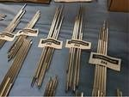

5 | schanz screws | Swiss / Synthes |  | brand: Swiss / Synthes; | 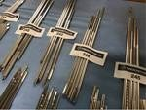
5 | schanz screws | Swiss / Synthes |  | brand: Swiss / Synthes; | 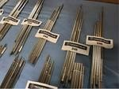
5 | schanz screws | Swiss / Synthes |  | brand: Swiss / Synthes; | 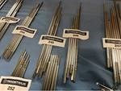
7 | schanz screws | Swiss / Synthes |  | brand: Swiss / Synthes; | 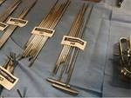
5 | schanz pins | Swiss / Synthes |  | brand: Swiss / Synthes; | 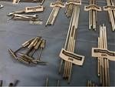
5 | schanz screws | Swiss / Synthes |  | brand: Swiss / Synthes; | 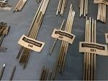
5 | schanz screws | Swiss / Synthes |  | brand: Swiss / Synthes; | 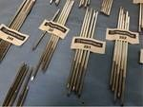

5 | schanz screws | Swiss / Synthes |  | brand: Swiss / Synthes; | 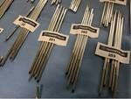
5 | schanz screws | Swiss / Synthes |  | brand: Swiss / Synthes; | 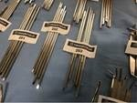
5 | schanz screws | Swiss / Synthes |  | brand: Swiss / Synthes; | 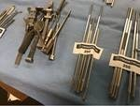
5 | schanz screws | Swiss / Synthes |  | brand: Swiss / Synthes; | 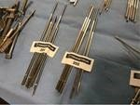
6 | suction tubes |  |  |  | 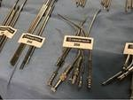
7 | suction tubes |  |  |  | 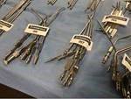
8 | suction tubes |  |  |  | 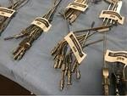

5 | suction tubes |  |  |  | 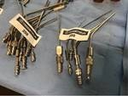
1 | driver cap with single outer sleeve | Medtronic |  | brand: Medtronic; | 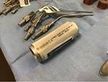
1 | targeting guides | Acumed |  | brand: Acumed; | 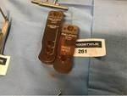
8 | surgical tools |  |  |  | 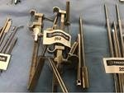
5 | double drill sleeves |  |  | brand: Swiss / Synthes;
5 | double drill sleeves |  |  | brand: Swiss / Synthes;
2 | retractors |  |  |  | 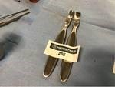
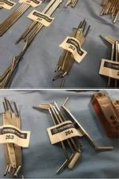

5 | retractors |  |  |  | 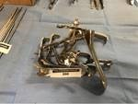
2 | retractors | Phimed |  | brand: Phimed; | 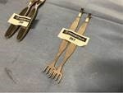
3 | surgical tools |  |  |  | 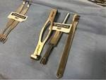
4 | hemostatic forceps |  |  |  | 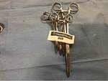
5 | pliers |  |  |  | 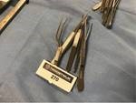
5 | T-handles | Swiss / Synthes |  | brand: Swiss / Synthes; | 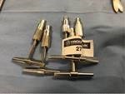
5 | forceps |  |  | description: stainless steel; | 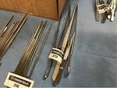

6 | pliers |  |  | description: stainless steel; | 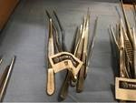
5 | pliers |  |  | description: stainless steel; | 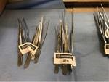
5 | forceps |  |  | description: stainless steel; | 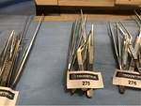
5 | pliers |  |  | description: stainless steel; | 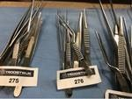
5 | pliers |  |  | description: stainless steel; | 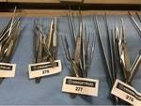
5 | forceps |  |  | description: stainless steel; | 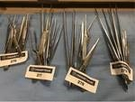
5 | pliers |  |  | description: stainless steel; | 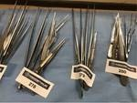

5 | forceps |  |  | description: stainless steel; | 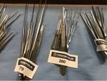
5 | pliers |  |  | description: stainless steel; | 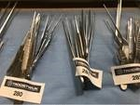
5 | pliers |  |  | description: stainless steel; | 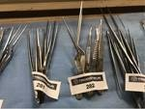
5 | forceps |  |  | description: stainless steel; | 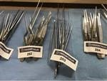
5 | pliers |  |  | description: stainless steel; | 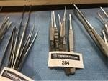
5 | forceps |  |  | description: stainless steel; | 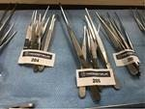
5 | pliers |  |  | description: stainless steel; | 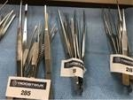

5 | forceps |  |  | description: stainless steel; | 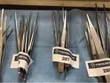
5 | pliers |  |  | description: stainless steel; | 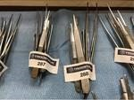
5 | forceps |  |  | description: stainless steel; | 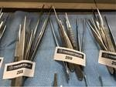
5 | pliers |  |  | description: stainless steel; | 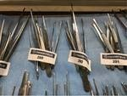
5 | forceps |  |  | description: stainless steel; | 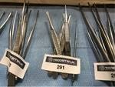
5 | pliers |  |  | description: stainless steel; | 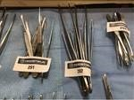
5 | forceps |  |  | description: stainless steel; | 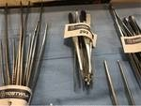

5 | pliers |  |  | description: stainless steel; | 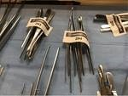
5 | forceps |  |  | description: stainless steel; | 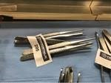
5 | pliers |  |  | description: stainless steel; | 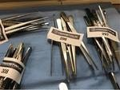
5 | forceps |  |  | description: stainless steel; | 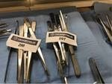
5 | pliers |  |  | description: stainless steel; | 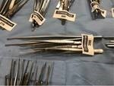
5 | forceps |  |  | description: stainless steel; | 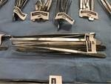
5 | pliers |  |  | description: stainless steel; | 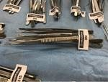

5 | forceps |  |  | description: stainless steel; | 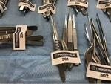
5 | forceps |  |  | description: stainless steel; | 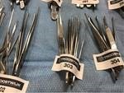
5 | pliers |  |  | description: stainless steel; | 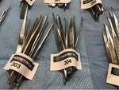
5 | forceps |  |  | description: stainless steel; | 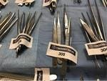
5 | pliers |  |  | description: stainless steel; | 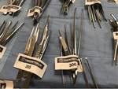
5 | forceps |  |  | description: stainless steel; | 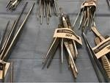
5 | pliers |  |  | description: stainless steel; | 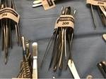

5 | forceps |  |  | description: stainless steel; | 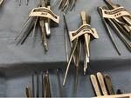
5 | pliers |  |  | description: stainless steel; | 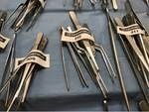
5 | pliers |  |  | description: stainless steel; | 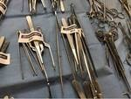
5 | forceps |  |  | description: stainless steel; | 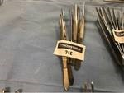
10 | pliers |  |  | description: stainless steel; | 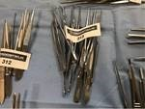
5 | forceps |  |  | description: stainless steel; | 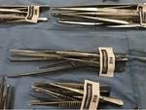
5 | pliers |  |  | description: stainless steel; | 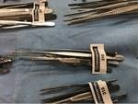

5 | forceps |  |  | description: stainless steel; | 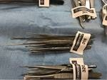
5 | pliers |  |  | description: stainless steel; | 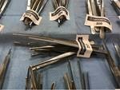
5 | forceps |  |  | description: stainless steel; | 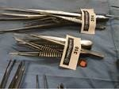
5 | pliers |  |  | description: stainless steel; | 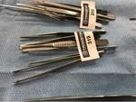
5 | forceps |  |  | description: stainless steel; | 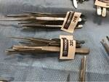
5 | pliers |  |  | description: stainless steel; | 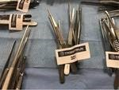
5 | forceps |  |  | description: stainless steel; | 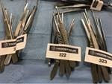

5 | pliers |  |  | description: stainless steel; | 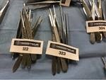
5 | forceps |  |  | description: stainless steel; | 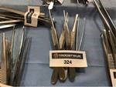
5 | pliers |  |  | description: stainless steel; | 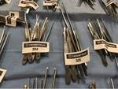
5 | forceps |  |  | description: stainless steel; | 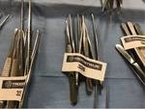
5 | pliers |  |  | description: stainless steel; | 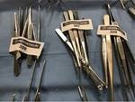
5 | pliers |  |  | description: stainless steel; | 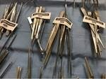
5 | forceps |  |  | description: stainless steel; | 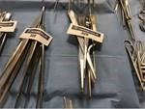

5 | pliers |  |  | description: stainless steel; | 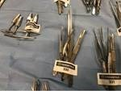
5 | forceps |  |  | description: stainless steel; | 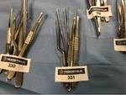
5 | pliers |  |  | description: stainless steel; | 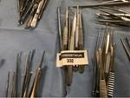
5 | pliers |  |  | description: stainless steel; | 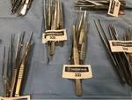
5 | forceps |  |  | description: stainless steel; | 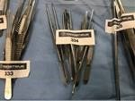
5 | pliers |  |  | description: stainless steel; | 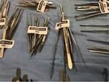
5 | forceps |  |  | description: stainless steel; | 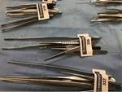

5 | pliers |  |  | description: stainless steel; | 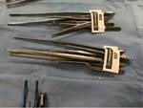
5 | pliers |  |  | description: stainless steel; | 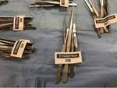
5 | forceps |  |  | description: stainless steel; | 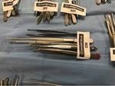
5 | pliers |  |  | description: stainless steel; | 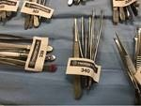
5 | forceps |  |  | description: stainless steel; | 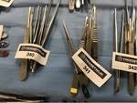
5 | pliers |  |  | description: stainless steel; | 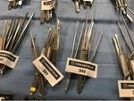
5 | forceps |  |  | description: stainless steel; | 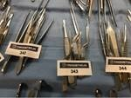

5 | pliers |  |  | description: stainless steel; | 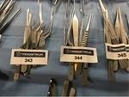
5 | forceps |  |  | description: stainless steel; | 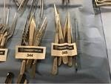
5 | pliers |  |  | description: stainless steel; | 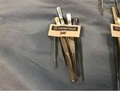
5 | forceps |  |  | description: stainless steel; | 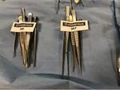
4 | pliers |  |  | description: stainless steel; | 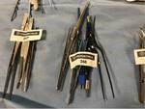
5 | forceps |  |  | description: stainless steel; | 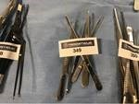
5 | pliers |  |  | description: stainless steel; | 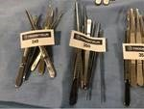

5 | forceps |  |  | description: stainless steel; | 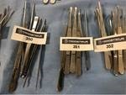
5 | pliers |  |  | description: stainless steel; | 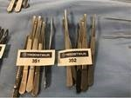
5 | forceps |  |  | description: stainless steel; | 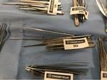
5 | pliers |  |  | description: stainless steel; | 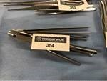
5 | forceps |  |  | description: stainless steel; | 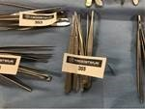
5 | pliers |  |  | description: stainless steel; | 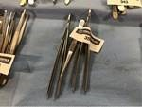
5 | forceps |  |  | description: stainless steel; | 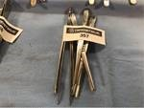

5 | haemostatic forceps |  |  |  | 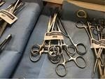
5 | hemostatic forceps |  |  |  | 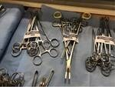
5 | haemostatic forceps |  |  |  | 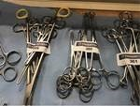
5 | hemostatic forceps |  |  |  | 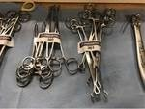
5 | haemostatic forceps |  |  |  | 
5 | hemostatic forceps |  |  |  | 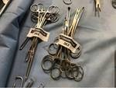
5 | hemostatic forceps |  |  |  | 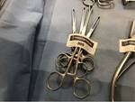

1 | tweezers |  |  | description: stainless steel; | 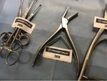
2 | bone holding forceps | Swiss / Synthes |  | brand: Swiss / Synthes; | 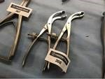
4 | osteotome |  |  |  | 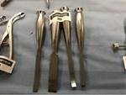
1 | bone holding pliers |  |  |  | 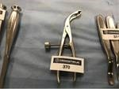
3 | retractors |  |  |  | 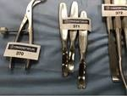
2 | bone curettes |  |  |  | 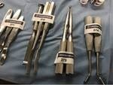
2 | osteotome | Innomed |  | brand: Innomed; | 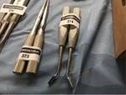

9 | gingival cord packer | Hu-Friedy |  | brand: Hu-Friedy; | 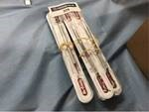
10 | osteotome |  |  |  | 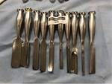
1 | sauerbruch bone forcep | Pilling |  | fire: Pilling; | 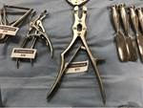
2 | bone holding forceps |  |  |  | 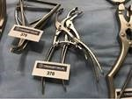
2 | retractors |  |  |  | 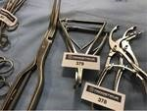
1 | distractor | Medtronic |  | brand: Medtronic; | 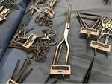
1 | extension bar | Aesculap |  | fire: Aesculap; | 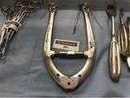

7 | retractors |  |  |  | 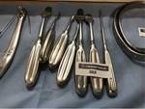
2 | surgical fixation tools |  |  |  | 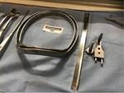
1 | retractor | Sklar |  | brand: Sklar; | 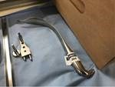
1 | lot of paramedic shears | Medco |  | brand: Medco; description: 5 1/2  ”; black; | 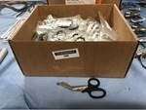
2 | collet mounting | Stryker | 4100-62 | brand: Stryker; type: 4100-62; | 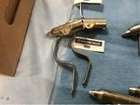
2 | wire collet attachment | Stryker | 4100-62 | brand: Stryker; type: 4100-62; | 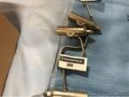
2 | collet mounting | Stryker | 4100-62 | brand: Stryker; type: 4100-62; | 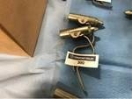

2 | wire collet attachment | Stryker | 4100-62 | brand: Stryker; type: 4100-62; | 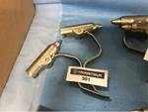
2 | wire collet attachment | Stryker | 4100-62 | brand: Stryker; type: 4100-62; | 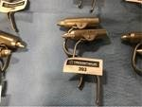
2 | collet mounting | Stryker | 4100-62 | brand: Stryker; type: 4100-62; | 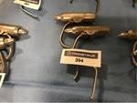
2 | pin collet attachment various | Stryker |  | brand: Stryker; | 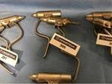
2 | thread and pin collet fastener | Stryker | 4100-62 /  4100-125 | brand: Stryker; type: 4100-62 / 4100-  125; | 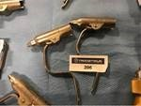
2 | pin collet attachment various | Stryker |  | brand: Stryker; | 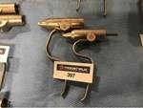
2 | collet mounting | Stryker | 4100-62 | brand: Stryker; type: 4100-62; | 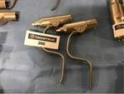

2 | pin collet attachment various | Stryker |  | brand: Stryker; | 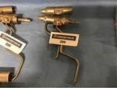
1 | pin collet mounting | Stryker | 4100-125 | brand: Stryker; type: 4100-125; | 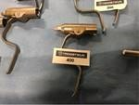
1 | adapter | AY  Corporation | IIC-301 | brand: AY Corporation; type: IIC-301; | 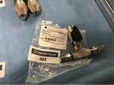
2 | reamer attachment | Stryker | 4100-210 | brand: Stryker; type: 4100-210; | 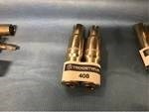
1 | reamer attachment | Stryker | 4100-210 | brand: Stryker; type: 4100-210; | 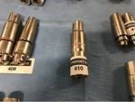
2 | wider confirmation | Stryker | 4100-231 | brand: Stryker; type: 4100-231; | 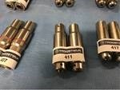
2 | drill attachment | Stryker | 4100-131 | brand: Stryker; type: 4100-131; | 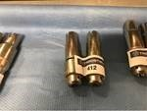

2 | keyless drill mounting | Stryker | 4100-133 | brand: Stryker; type: 4100-133; | 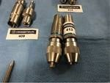
2 | drill attachment | Stryker | 4100-132 | brand: Stryker; type: 4100-132; | 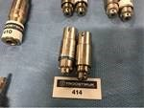
2 | drill mounting | Stryker | 4100-132 | brand: Stryker; type: 4100-132; | 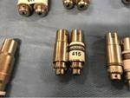
2 | drill attachment | Stryker | 4100-131 | brand: Stryker; type: 4100-131; | 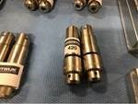
2 | instrument cassette | Hu-Friedy | IMOS8 | brand: Hu-Friedy; type: IMOS8; total dimension L: 370 mm; total dimension B: 200 mm; total dimension H: 30 mm; description: stainless steel; unused; | 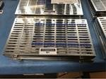
2 | instrument cassette | Hu-Friedy | IMOS8 | brand: Hu-Friedy; type: IMOS8; total dimension L: 370 mm; total dimension W: 200 mm; total dimension H: 30 mm; description: stainless steel; unused; | 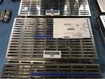
2 | instrument cassette | Hu-Friedy | IMOS8 | brand: Hu-Friedy; type: IMOS8; total dimension L: 370 mm; total dimension B: 200 mm; total dimension H: 30 mm; description: stainless steel; unused; | 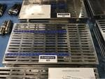

2 | instrument cassette | Hu-Friedy | IMOS8 | brand: Hu-Friedy; type: IMOS8; total dimension L: 370 mm; total dimension W: 200 mm; total dimension H: 30 mm; description: stainless steel; unused; | 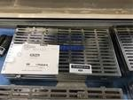
2 | instrument cassette | Hu-Friedy | IMOS8 | brand: Hu-Friedy; type: IMOS8; total dimension L: 370 mm; total dimension B: 200 mm; total dimension H: 30 mm; description: stainless steel; unused; | 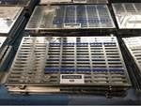
2 | instrument cassette | Hu-Friedy | IMOS8 | brand: Hu-Friedy; type: IMOS8; total dimension L: 370 mm; total dimension W: 200 mm; total dimension H: 30 mm; description: stainless steel; unused; | 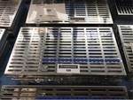
2 | instrument cassette | Hu-Friedy | IMOS8 | brand: Hu-Friedy; type: IMOS8; total dimension L: 370 mm; total dimension B: 200 mm; total dimension H: 30 mm; description: stainless steel; unused; | 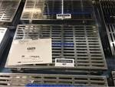
1 | cannulated screw case | Synthes |  | brand: Synthes; description: titanium; empty; 4.5 mm; | 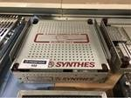
1 | double decker tube rocker | Unico | L-TTR-200D | brand: Unico; type: L-TTR- 200D; description: max.cap. 30 tubes; 115V; | 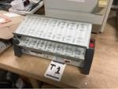
1 | oxygen bubble tube | Covidien | Argyle | brand: Covidien; type: Argyle; | 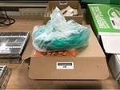

1 | infusion pump monitor module | Carefusion | Alaris EtCO2 8300 | brand: Carefusion; type: Alaris EtCO2 8300; digital display:  yes; description: (working unknown!); | 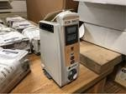
1 | infusion pump monitor module | Carefusion | Alaris EtCO2 8300 | brand: Carefusion; type: Alaris EtCO2 8300; digital readout:  yes; description: (works unknown!);
1 | infusion pump monitor module | Carefusion | Alaris EtCO2 8300 | brand: Carefusion; type: Alaris EtCO2 8300; digital display:  yes; description: (working unknown!);
1 | infusion pump monitor module | Carefusion | Alaris EtCO2 8300 | brand: Carefusion; type: Alaris EtCO2 8300; digital readout:  yes; description: (works unknown!);
1 | infusion pump monitor module | Carefusion | Alaris EtCO2 8300 | brand: Carefusion; type: Alaris EtCO2 8300; digital display:  yes; description: (working unknown!);
1 | air purifying respirator | SafetyTech | C420 | brand: SafetyTech; type: C420; | 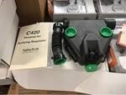
1 | air purifying dust mask | SafetyTech | C420 | brand: SafetyTech; type: C420;

1 | air purifying respirator | SafetyTech | C420 | brand: SafetyTech; type: C420;
2 | air purifying respirator | SafetyTech | C420 | brand: SafetyTech; type: C420;
2 | air purifying dust mask | SafetyTech | C420 | brand: SafetyTech; type: C420;
2 | air purifying dust mask | SafetyTech | C420 | brand: SafetyTech; type: C420;
2 | air purifying dust mask | SafetyTech | C420 | brand: SafetyTech; type: C420;
4 | air purifying respirator | SafetyTech | C420 | brand: SafetyTech; type: C420;
4 | air purifying dust mask | SafetyTech | C420 | brand: SafetyTech; type: C420;

1 | continous intermittent suction aspirator | Impact Ultra- Lite | 326 / 326M | brand: Impact Ultra-Lite; type: 326 / 326M; description: unserviceable; | 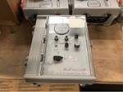
1 | continuous intermittent suction axis | Impact Ultra- Lite | 326 / 326M | brand: Impact Ultra-Lite; type: 326 / 326M; description: unusable;
1 | continous intermittent suction aspirator | Impact Ultra- Lite | 326 / 326M | brand: Impact Ultra-Lite; type: 326 / 326M; description: unserviceable;
1 | continuous intermittent suction axis | Impact Ultra- Lite | 326 / 326M | brand: Impact Ultra-Lite; type: 326 / 326M; description: unusable;
1 | continous intermittent suction aspirator | Impact Ultra- Lite | 326 / 326M | brand: Impact Ultra-Lite; type: 326 / 326M; description: unserviceable;
1 | continuous intermittent suction axis | Impact Ultra- Lite | 326 / 326M | brand: Impact Ultra-Lite; type: 326 / 326M; description: unusable;
1 | continous intermittent suction aspirator | Impact Ultra- Lite | 326 / 326M | brand: Impact Ultra-Lite; type: 326 / 326M; description: unserviceable;

1 | continuous intermittent suction axis | Impact Ultra- Lite | 326 / 326M | brand: Impact Ultra-Lite; type: 326 / 326M; description: unusable;
1 | continous intermittent suction aspirator | Impact Ultra- Lite | 326 / 326M | brand: Impact Ultra-Lite; type: 326 / 326M; description: unserviceable;
1 | continuous intermittent suction axis | Impact Ultra- Lite | 326 / 326M | brand: Impact Ultra-Lite; type: 326 / 326M; description: unusable;
1 | continous intermittent suction aspirator | Impact Ultra- Lite | 326 / 326M | brand: Impact Ultra-Lite; type: 326 / 326M; description: unserviceable;
1 | continuous intermittent suction axis | Impact Ultra- Lite | 326 / 326M | brand: Impact Ultra-Lite; type: 326 / 326M; description: unusable;
1 | continuous intermittent suction axis | Impact Ultra- Lite | 326 / 326M | brand: Impact Ultra-Lite; type: 326 / 326M; description: unusable;
1 | continous intermittent suction aspirator | Impact Ultra- Lite | 326 / 326M | brand: Impact Ultra-Lite; type: 326 / 326M; description: unserviceable;

1 | infusion pump controller | Cardinal Health | Alaris 8015 | brand: Cardinal Health; type: Alaris 8015; digital readout:  yes; connection: 230 V; description: unusable; | 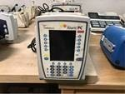
1 | infusion pump controller | Cardinal Health | Alaris 8015 | brand: Cardinal Health; type: Alaris 8015; digital readout:  yes; connection: 230 V; description: unusable;
1 | ultrasonic therapy unit | Chattanooga | Intelect Legend Combo | brand: Chattanooga; type: Intelect Legend Combo; | 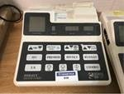
1 | many power cables | Thermal Angel |  | brand: Thermal Angel; description: for blood liquid warmer; in 3 boxes; | 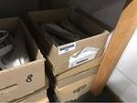
1 | lot of power cables | Thermal Angel |  | brand: Thermal Angel; description: for blood fluid warmer; in 3 boxes;
1 | lot of power cables | Thermal Angel |  | brand: Thermal Angel; description: for blood fluid warmer; in 3 boxes; | 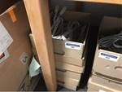
29 | cervical collar | DeRoyal | 1000401 | brand: DeRoyal; type: 1000401; description: medium  foam; 22 x 4 inches; | 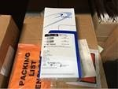

120 | drinking water storage bags |  |  | description: size B; 3 pints; | 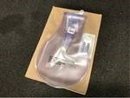
120 | drinking water storage bags |  |  | description: size B; 3 pints;
120 | drinking water storage bags |  |  | description: size B; 3 pints;
50 | handheld nebulizers | Hudson | RCI 1720 | brand: Hudson; type: RCI 1720; | 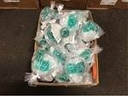
50 | portable nebulizers | Hudson | RCI 1720 | brand: Hudson; type: RCI 1720;
50 | handheld nebulizers | Hudson | RCI 1720 | brand: Hudson; type: RCI 1720;
50 | portable nebulizers | Hudson | RCI 1720 | brand: Hudson; type: RCI 1720;

50 | handheld nebulizers | Hudson | RCI 1720 | brand: Hudson; type: RCI 1720;
50 | handheld nebulizers | Hudson | RCI 1720 | brand: Hudson; type: RCI 1720;
50 | handheld nebulizers | Hudson | RCI 1720 | brand: Hudson; type: RCI 1720;
50 | portable nebulizers | Hudson | RCI 1720 | brand: Hudson; type: RCI 1720;
50 | handheld nebulizers | Hudson | RCI 1720 | brand: Hudson; type: RCI 1720;
10 | pump infusion blood set | BD | Alaris 2477-  0007 | brand: BD; type: Alaris 2477- 0007; description: 180 micron filter; inbox; | 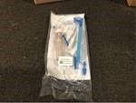
10 | pump infusion blood set | BD | Alaris 2477-  0007 | brand: BD; type: Alaris 2477- 0007; description: 180 micron filter; in box;

10 | pump infusion blood set | BD | Alaris 2477-  0007 | brand: BD; type: Alaris 2477- 0007; description: 180 micron filter; inbox;
50 | catheter trays with graduations | Covidien | Argyle | brand: Covidien; type:  Argyle; description: with chimney valve; | 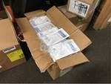
30 | Epump set with flush bag | Covidien | Kangaroo | brand: Covidien; type:  Kangaroo; description: with chimney valve; | 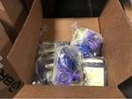
200 | small bore extension set | Icu medical | B2010 | brand: Icu medical; type: B2010; description: in 4 boxes; | 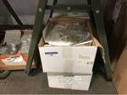
48 | disposable berman airways | Medline | DYND60425 | brand: Medline; type: DYND60425; | 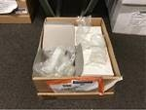
50 | dry sterile burn dressing cravats | North American Rescue |  | brand: North American Rescue; description: size XL; | 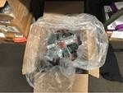
50 | spray bulb | Busse | 143 | brand: Busse; type: 143; description: 3 Oz; inbox; | 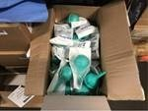

50 | bulb syringes | Busse | 143 | brand: Busse; type: 143; description: 3 Oz; in box;
40 | spike luer adapters | ambIT | 220332 | brand: ambIT; type:  220332; description: with cap; | 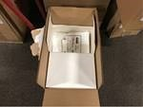
40 | spike luer adapters | ambIT | 220332 | brand: ambIT; type:  220332; description: with cap;
80 | spike luer adapters | ambIT | 220332 | brand: ambIT; type:  220332; description: with cap;
168 | chest of drawers liners | Carex | P709-00 | brand: Carex; type: P709-00; | 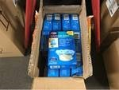
2000 | regular tongue depressors | Puritan | 705 | brand: Puritan; type: 705; | 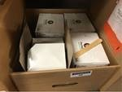
1 | many pre- programmed towels | Cardinal Health | GV287-04 | brand: Cardinal Health; type: GV287- 04; description: blue; inbox; | 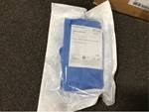

1000 | aprons | Dynarex | 4403 | brand: Dynarex; type: 4403; description: 24x42 "; | 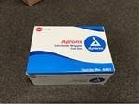
1000 | aprons | Dynarex | 4403 | brand: Dynarex; type: 4403; description: 24x42 ";
1 | microscope | Richter Optics | BX51TF | brand: Richter Optica; type: BX51TF; transparent:  yes; connection: 230 V; description: with (4x) lenses; tilting head and halogen lamp housing; | 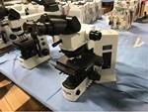
1 | trinocular microscope | Leica | DMRB 301-  371010 | brand: Leica; type: DMRB 301- 371,010; transparent:  yes; connection: 230 V; description: with (4x) objectives and lamp housing; | 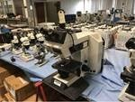
1 | microscope | National |  | brand: National; stereo: no; | 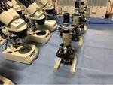
1 | microscope | National |  | brand: National; stereo: no; | 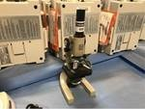
1 | microscope | Boreal |  | brand: Boreal; stereo: yes; connection: 115 V; | 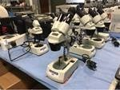

1 | microscope | Boreal |  | brand: Boreal; stereo: yes; electric connection: 115 V; | 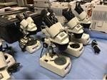
1 | microscope | Boreal |  | brand: Boreal; stereo: yes; connection: 115 V; | 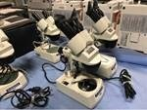
3 | cushion inserts | Mizuho | Proneview D28503CE | brand: Mizuho; type: Proneview D28503CE; description: for protective helmets; size L; | 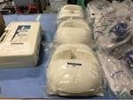
5 | shoulder sleeves | Game Ready | 510434 | brand: Game Ready; type: 510434; description: Large; left; | 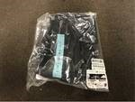
3 | orthotic support sets | Powerstep | CustomPost | brand: Powerstep; type: CustomPost; | 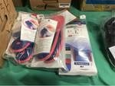
21 | cock-up wrist | DeRoyal | 5022-07 | brand: DeRoyal; type: 5022-  07; description: splint adjustable; 8  ”; medium; left; | 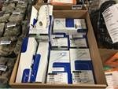
300 | shoe covers |  |  | description: blue; size Large; in box; | 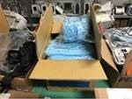

2 | first aid kit pouches |  |  |  | 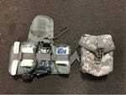
3 | First aid bags
3 | first aid kit pouches
3 | First aid bags
3 | first aid kit pouches
2 | body fluids barrier kit |  |  |  | 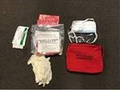
3 | body fluids barrier kit

4 | trauma modules | The Emergency Bandage |  | brand: The Emergency Bandage; | 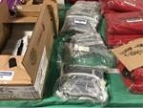
4000 | adult resting tab ECG electrodes | ConMed | V-Trace | brand: ConMed; type: V- Trace; description: in box; | 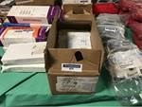
1 | different blood pressure cuffs | Welch Allyn |  | brand: Welch Allyn; description: in 2 boxes; | 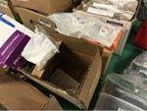
12 | flexible cohesive bandages | Co-Flex | 5600S | brand: Co-Flex; type: 5600S; | 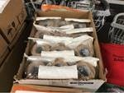
160 | blood pressure cuffs | Critikon | 2524 Soft- Cuf | brand: Critikon; type: 2524 Soft-Cuf; | 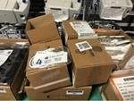
5 | knee brace response | Donjoy | 11-0215-4 | brand: Donjoy; type: 11-0215- 4; description: XL / XXL; gray; | 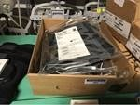
10 | various medical supplies |  |  | description: ao braces; straps and gloves; | 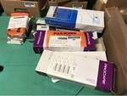

1 | T-POD combat pelvic stabilization device | Two Rivers Medical | TRM11174 4 | brand: Two Rivers Medical; type: TRM111744; | 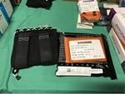
384 | super fast singles | Shofu | PN 0501 | brand: Shofu; type: PN 0501; | 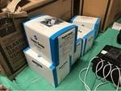
96 | stretch bandage | Covidien | Curity 2236 | brand: Covidien; type: Curity 2236; | 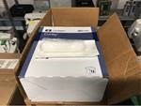
1000 | catheter dressings | ConMed | Veni-Gard SP 710-  2730 | brand: ConMed; type: Veni-Gard SP 710-2730; description: inbox; | 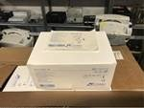
1000 | catheter dressings | ConMed | Veni-Gard SP 710-  2730 | brand: ConMed; type: Veni-Gard SP 710-2730; description: in box;
144 | flexible cohesive relationships | Co-Flex | TAN | brand: Co-Flex; type:  TAN; description: 1.5 ”; | 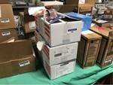
1000 | specimen bags | Biohazard |  | brand: Biohazard; description: 6x9 ”; | 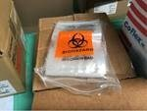

6 | blood bag systems | Terumo | Teruflex | brand: Terumo; type:  Teruflex; description: with blood collection arm; | 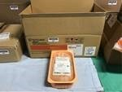
120 | EKG chart paper pads | Medichoice |  | brand: Medichoice; description: 200 sheets / pad; 90x90 mm; | 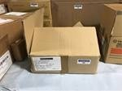
20 | sharp safety containers | Kendall | 8303SA | brand: Kendall; type: 8303SA; | 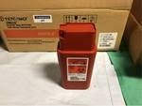
24 | FMS tubing sets | DePuy Mitek | 281142 | brand: DePuy Mitek; type: 281142; | 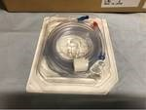
2000 | luer adapters | Greiner Bio- One | Vacuette | brand: Greiner Bio-One; type: Vacuette; description: 100 pieces / box; | 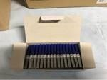
2000 | luer adapters | Greiner Bio- One | Vacuette | brand: Greiner Bio-One; type: Vacuette; description: 100 pcs./box;
60 | non-woven adhesive bandages | Cover-Roll | Stretch 45548-00 | brand: Cover-Roll; type: Stretch 45548-00; description: 12 pieces /  box; 5 boxes; | 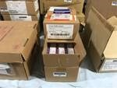

2000 | sterilization pouches | Wipak Medical | Steriking SS10 | brand: Wipak Medical; type: Steriking SS10; description: in 2 boxes; | 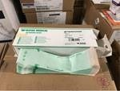
3000 | sterilization pouches | Wipak Medical | Steriking SS10 | brand: Wipak Medical; type: Steriking SS10; description: in 2 boxes;
10 | replacement cuffs | Omron |  | brand: Omron; | 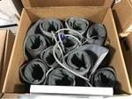
100 | disposable graves of vaginal speculas | Sklar Instruments | Sklarspec | brand: Sklar Instruments; type: Sklarspec; description: large size; 10x specula / bag; | 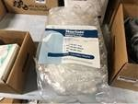
25 | soft silicone foam dressings | Mepilex | Border Sacrum AG | brand: Mepilex; type: Border Sacrum AG; | 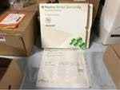
24 | surgical tape rolls | 3M | Durapore | brand: 3M; type:  Durapore; description: 3 ”; | 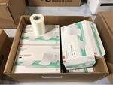
12 | bus brackets | Metrex | CarviWipes | brand: Metrex; type: CarviWipes; | 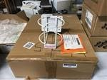

1000 | sterilization pouches | Wipak Medical | Steriking SS- T2 | brand: Wipak Medical; type: Steriking SS-T2; description: in 2 boxes; | 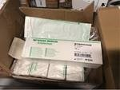
7250 | covers for the thermometer | Welch Allyn | 5031 | brand: Welch Allyn; type:  05031; description: 250 pieces / box; | 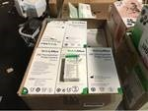
1 | many specimen bags |  |  |  | 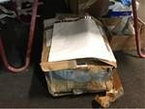
2 | terry slings | Chattanooga |  | brand: Chattanooga; | 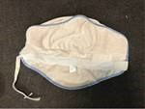
24 | arm slings | DeRoyal | 8017-02 | brand: DeRoyal; type: 8017- 02; description: medium; | 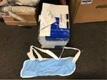
40 | analytical funnels | Nalgene |  | brand: Nalgene; description: size 100 mm; | 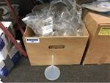
36 | pump sets | Sherwood | Kangaroo | brand: Sherwood; type: Kangaroo; description: 500 ml; | 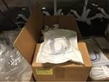

50 | gastric tubes with double lumen | Covidien | Salem Sump | brand: Covidien; type: Salem Sump; | 
1 | lot of protective caps |  |  |  | 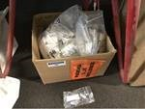
16 | unitary wash bottles | Nalgene |  | brand: Nalgene; description: 250 ml; | 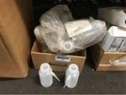
1 | many adult speculas for single use | Welch Allyn | KleenSpec | brand: Welch Allyn; type: KleenSpec; description: 850 pieces / bag; in 7 bags; | 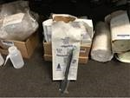
2000 | transparent clear bags | Coreless Rolls |  | brand: Coreless Rolls; description:  24x24 ”; | 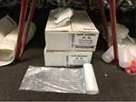
1 | lot or non metallic tubing |  |  |  | 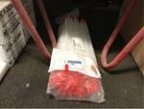
50 | spray bulb | Covidien | Dover 67000 | brand: Covidien; type: Dover 67000; description: irrigation with protective cover; 60 ml; | 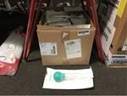

48 | scrub shirts | Halyard | 69701 | brand: Halyard; type:  69701; description: size medium; | 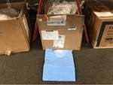
1150 | gauze sponges | Covidien | Curity | brand: Covidien; type: Curity; description: 4x4 "; | 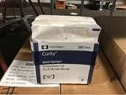
50 | exam shorts | Medishorts |  | brand: Medishorts; description: size Lg / XLg; | 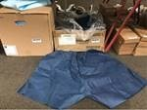
13 | plastic medical containers |  |  |  | 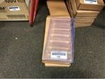
13 | plastic medical containers
20 | blood infusion sets | CareFusion | Smartsite 28080E | brand: CareFusion; type: Smartsite 28080E; | 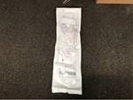
20 | blood infusion sets | CareFusion | Smartsite 28080E | brand: CareFusion; type: Smartsite 28080E;

40 | blood infusion sets | CareFusion | Smartsite 28080E | brand: CareFusion; type: Smartsite 28080E;
24 | large drape sheets | CardinalHealt h | Converters 9444 | brand: CardinalHealth; type: Converters 9444; description: blue; in 2 boxes; | 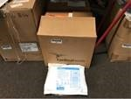
65 | film split drapes | Halyard | 88660 | brand: Halyard; type: 88660; | 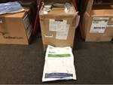
200 | utility curtains with tape | Halyard | 89731 | brand: Halyard; type: 89731; description: two in a package; 100 packs; | 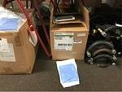
1 | lot or overnight pads | Kotex |  | brand: Kotex; description: 14 pcs./bag; in 14 bags; | 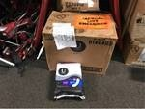
1250 | transparent covers | Microtek | 17589 | brand: Microtek; type: 17589; description: for X-Ray machines; in 5 boxes; | 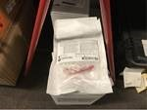
20 | blizzard survival blanket | PerSys Medical | BPS-01 | brand: PerSys Medical; type: BPS-01; | 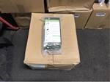

20 | blizzard survival blanket | PerSys Medical | BPS-01 | brand: PerSys Medical; type: BPS-01;
20 | blizzard survival blanket | PerSys Medical | BPS-01 | brand: PerSys Medical; type: BPS-01;
20 | blizzard survival blanket | PerSys Medical | BPS-01 | brand: PerSys Medical; type: BPS-01;
1 | surgical transducer | Conet | SST 300 | brand: Conet; type: SST  300; connection: 230 V; description:  120 / 220V; | 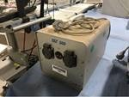
1 | surgical smoke evacuator | ValleyLab | RapidVac SE3695 | brand: ValleyLab; type: RapidVac SE3695; electric connection: 230 V; | 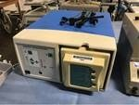
1 | continous intermittent suction aspirator | Impact Ultra- Lite | 326 / 326M | brand: Impact Ultra-Lite; type: 326 / 326M; | 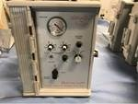
1 | continuous intermittent suction axis | Impact Ultra- Lite | 326 / 326M | brand: Impact Ultra-Lite; type: 326 / 326M;

1 | continuous intermittent suction axis | Impact Ultra- Lite | 326 / 326M | brand: Impact Ultra-Lite; type: 326 / 326M;
1 | continous intermittent suction aspirator | Impact Ultra- Lite | 326 / 326M | brand: Impact Ultra-Lite; type: 326 / 326M;
1 | continuous intermittent suction axis | Impact Ultra- Lite | 326 / 326M | brand: Impact Ultra-Lite; type: 326 / 326M;
1 | continous intermittent suction aspirator | Impact Ultra- Lite | 326 / 326M | brand: Impact Ultra-Lite; type: 326 / 326M;
1 | continuous intermittent suction axis | Impact Ultra- Lite | 326 / 326M | brand: Impact Ultra-Lite; type: 326 / 326M;
1 | continous intermittent suction aspirator | Impact Ultra- Lite | 326 / 326M | brand: Impact Ultra-Lite; type: 326 / 326M;
1 | continuous intermittent suction axis | Impact Ultra- Lite | 326 / 326M | brand: Impact Ultra-Lite; type: 326 / 326M;

1 | continous intermittent suction aspirator | Impact Ultra- Lite | 326 / 326M | brand: Impact Ultra-Lite; type: 326 / 326M;
1 | continuous intermittent suction axis | Impact Ultra- Lite | 326 / 326M | brand: Impact Ultra-Lite; type: 326 / 326M;
1 | continous intermittent suction aspirator | Impact Ultra- Lite | 326 / 326M | brand: Impact Ultra-Lite; type: 326 / 326M;
1 | continuous intermittent suction axis | Impact Ultra- Lite | 326 / 326M | brand: Impact Ultra-Lite; type: 326 / 326M;
1 | continous intermittent suction aspirator | Impact Ultra- Lite | 326 / 326M | brand: Impact Ultra-Lite; type: 326 / 326M;
1 | continuous intermittent suction axis | Impact Ultra- Lite | 326 / 326M | brand: Impact Ultra-Lite; type: 326 / 326M;
1 | continous intermittent suction aspirator | Impact Ultra- Lite | 326 / 326M | brand: Impact Ultra-Lite; type: 326 / 326M;

1 | continuous intermittent suction axis | Impact Ultra- Lite | 326 / 326M | brand: Impact Ultra-Lite; type: 326 / 326M;
1 | continuous intermittent suction axis | Impact Ultra- Lite | 326 / 326M | brand: Impact Ultra-Lite; type: 326 / 326M;
1 | many toilet waste kits | Cleanwaste | GO | brand: Cleanwaste; type: GO; | 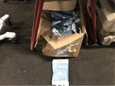
120 | sterilization packaging | Halyard | 62124 | brand: Halyard; type:  62124; description: 120 pieces / package; | 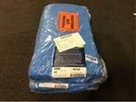
240 | sterilization wraps | Halyard | 12724 | brand: Halyard; type: 12724; description: 120 pcs./package; | 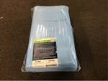
240 | sterilization packaging | Halyard | 12724 | brand: Halyard; type:  12724; description: 120 pieces / package;
500 | sterilization wraps | Halyard | 10724 | brand: Halyard; type: 10724; description: 120 pcs./package; | 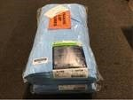

150 | impermeable boot covers | ICP Medical |  | brand: ICP Medical; description: knee high; | 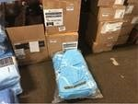
150 | impervious boot covers | ICP Medical |  | brand: ICP Medical; description: knee-high;
50 | gastric tubes with double lumen | Covidien | Salem Sump 888826496  0 | brand: Covidien; type: Salem Sump 8888264960; description: 50 pieces / box; | 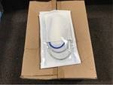
50 | gastric tubes with double lumen | Covidien | Salem Sump 888826496  0 | brand: Covidien; type: Salem Sump 8888264960; description: 50 pieces / box;
50 | dual lumen stomach tubes | Covidien | Salem Sump 888826496  0 | brand: Covidien; type: Salem Sump 8888264960; description: 50 pcs./box;
100 | gastric tubes with double lumen | Covidien | Salem Sump 888826496  0 | brand: Covidien; type: Salem Sump 8888264960; description: 50 pieces / box;
150 | dual lumen stomach tubes | Covidien | Salem Sump 888826496  0 | brand: Covidien; type: Salem Sump 8888264960; description: 50 pcs./box;

1 | electrosurgical unit | ConMed | Hyfrecator 2000 | brand: ConMed; type: Hyfrecator 2000; description: with mobile stand; | 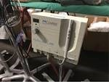
1 | digital amalgamator | SDS Kerr | Optimix | brand: SDS Kerr; type: Optimix; | 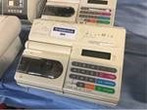
1 | digital amalgamator | SDS Kerr | Optimix | brand: SDS Kerr; type: Optimix; | 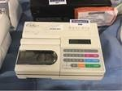
10 | military large field backpack | Molle II | Multicam | brand: Molle II; type:  Multicam; description: 9 pieces in backpack; | 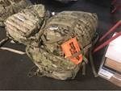
4 | military medium rucksack | Molle II |  | brand: Molle II; description: 3 pcs. in rucksack; | 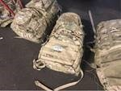
1 | lot of screw cap glass bottles | GSA |  | brand: GSA; | 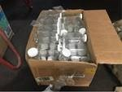
200 | pair of surgical undergloves | Biogel | 41685 | brand: Biogel; type:  41685; description: 50 pieces / box; | 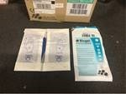

10 | fiberglass cast tape rolls | Delta Lite Plus |  | brand: Delta Lite Plus; description: 2  ”; | 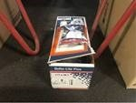
180 | plastic bags | Envision |  | brand: Envision; description: brown; 30 gallons; | 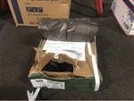
100 | thin-walled buses | Cardinal Health | J608-620 | brand: Cardinal Health; type: J608- 620; description: 1500 ml; | 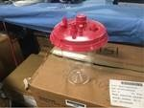
100 | thin-walled buses | Cardinal Health | J608-620 | brand: Cardinal Health; type: J608- 620; description: 1500 ml;
30 | two-tone bonded sterilization packs | Medline | GEMG4154 T | brand: Medline; type: GEMG4154T; description: 54 x 54 inches; | 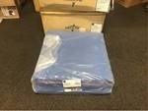
30 | two color bonded sterilization wraps | Medline | GEMG4154 T | brand: Medline; type:  GEMG4154T; description: 54x54 ”;
12 | exam table paper rolls | Medchoice |  | brand: Medchoice; description: crepe; white; | 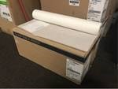

12 | exam table paper rolls | Medchoice |  | brand: Medchoice; description: crepe; white;
12 | examination table paper rolls | Medchoice |  | brand: Medchoice; description: crepe; white;
12 | exam table paper rolls | Medchoice |  | brand: Medchoice; description: crepe; white;
25 | adult nasal cannulas | Hudson | 1812 | brand: Hudson; type:  1812; description: with oxygen rigid lumen hoses; | 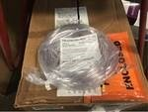
6 | sterile water packs | Hudson | Concha | brand: Hudson; type:  Concha; description: 1650 mL; with reservoirs; | 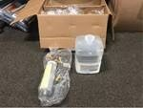
6 | sterile water packs | Hudson | Concha | brand: Hudson; type:  Concha; description: 1650 ml; with reservoirs;
200 | utility drapes with tape | Halyard | 89731 | brand: Halyard; type:  89731; description: two in one pack; 100 packs; | 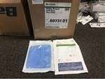

200 | utility curtains with tape | Halyard | 89731 | brand: Halyard; type: 89731; description: two in a package; 100 packs;
200 | utility curtains with tape | Halyard | 89731 | brand: Halyard; type: 89731; description: two in a package; 100 packs;
48 | interlink system extension sets | Baxter | 2C6605 | brand: Baxter; type:  2C6605; description: 48 pcs./box; | 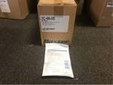
48 | interlink system extension sets | Baxter | 2C6605 | brand: Baxter; type:  2C6605; description: 48 pieces / box;
48 | interlink system extension sets | Baxter | 2C6605 | brand: Baxter; type:  2C6605; description: 48 pieces / box;
144 | interlink system extension sets | Baxter | 2C6605 | brand: Baxter; type:  2C6605; description: 48 pcs./box;
144 | interlink system extension sets | Baxter | 2C6605 | brand: Baxter; type:  2C6605; description: 48 pieces / box;

144 | interlink system extension sets | Baxter | 2C6605 | brand: Baxter; type:  2C6605; description: 48 pcs./box;
12 | adhesive plaster rolls | Andover | Moleskin | brand: Andover; type: Moleskin; description: 12x180 "; | 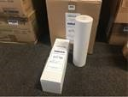
12 | adhesive plaster rolls | Andover | Moleskin | brand: Andover; type:  Moleskin; description: 12x180 ”;
50 | gastric tubes with double lumen | Covidien | Salem Sump 888826496  0 | brand: Covidien; type: Salem Sump 8888264960; description: 50 pieces / box; | 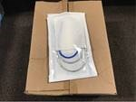
50 | dual lumen stomach tubes | Covidien | Salem Sump 888826496  0 | brand: Covidien; type: Salem Sump 8888264960; description: 50 pcs./box;
100 | gastric tubes with double lumen | Covidien | Salem Sump 888826496  0 | brand: Covidien; type: Salem Sump 8888264960; description: 50 pieces / box;
200 | lap sponges | Surgicount | Safety Sponge | brand: Surgicount; type: Safety- Sponge; description: 18x18 ”; 5 pcs./bag; | 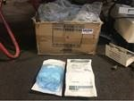

1 | defibrillator | ZOLL | AED PLUS | brand: ZOLL; type: AED  PLUS; automatic: yes; description: incl. bag; | 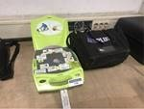
1 | defibrillator | Medtronic | LIFEPAK CR PLUS | brand: Medtronic; type: LIFEPAK CR PLUS; automatic: yes; audio guidance: yes; description: incl. bag; | 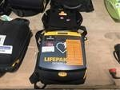
1 | defibrillator | Medtronic | LIFEPAK CR PLUS | brand: Medtronic; type: LIFEPAK CR PLUS; automatic: yes; audio instructions: yes; description: incl. bag; | 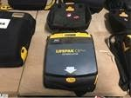
1 | defibrillator | Philips | Heartstart HS1 | brand: Philips; type: Heartstart  HS1; automatic: yes; audio guidance: yes; description: incl. wall cupboard and bad; | 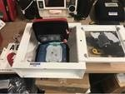
1 | defibrillator monitor | Philips | Heartstart MRx M3538A | brand: Philips; type: Heartstart MRx M3538A; automatic: yes; audio guidance: yes; description: incl. various belongings; | 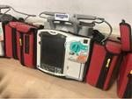
1 | easy wall mounting |  |  |  | 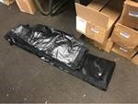
1 | easy wall mounting

1 | hematology analyzer | Beckman Coulter | Ac T Diff 2 | brand: Beckman Coulter; type: Ac T Diff 2; dimension L: 500  mm; dimension B: 400  mm; dimension H: 460 mm; | 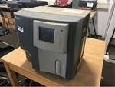
1 | ophthalmoscop e / otoscope | Welch Allyn |  | brand: Welch Allyn; description: with transformer; | 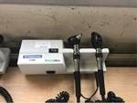
1 | ophthalmoscop e / otoscope | Welch Allyn |  | brand: Welch Allyn; description: with transformer; | 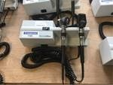
1 | ophthalmoscop e / otoscope | Welch Allyn |  | brand: Welch Allyn; description: with transformer; | 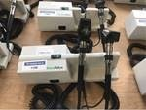
1 | ophthalmoscop e / otoscope | Welch Allyn |  | brand: Welch Allyn; description: with transformer; | 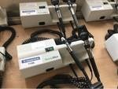
1 | ophthalmoscop e / otoscope | Welch Allyn |  | brand: Welch Allyn; description: with transformer; | 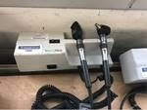
1 | ophthalmoscop e / otoscope set | Welch Allyn |  | brand: Welch Allyn; description: wall mounting; with blood pressure monitor and dispenser; | 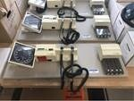

1 | ophthalmoscop e / otoscope set | Welch Allyn |  | brand: Welch Allyn; description: wall mount; with sphygmomanometer and dispenser; | 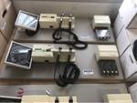
1 | ophthalmoscop e / otoscope set | Welch Allyn |  | brand: Welch Allyn; description: wall mounting; with blood pressure monitor and dispenser; | 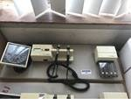
1 | wall mount diagnostic set | Welch Allyn | 77791- MX | brand: Welch Allyn; type: 77791- MX; description: with sphygmomanometer; cuff and dispenser; | 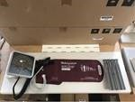
1 | thermometer | Welch Allyn | 670 | brand: Welch Allyn; type:  670; description: with probe; probe covers and wall mounting station; | 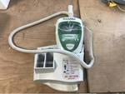
1 | thermometer | Welch Allyn | 670 | brand: Welch Allyn; type:  670; description: with probe; probe covers and wall mounting station;
1 | thermometer | Welch Allyn | 670 | brand: Welch Allyn; type:  670; description: with probe; probe covers and wall mounting station;
1 | thermometer | Welch Allyn | 670 | brand: Welch Allyn; type:  670; description: with probe; probe covers and wall mount station;

1 | thermometer | Welch Allyn | 670 | brand: Welch Allyn; type:  670; description: with probe; probe covers and wall mount station;
1 | thermometer | Welch Allyn | 670 | brand: Welch Allyn; type:  670; description: with probe; probe covers and wall mounting station;
1 | thermometer | Welch Allyn | 670 | brand: Welch Allyn; type:  670; description: with probe; probe covers and wall mount station;
1 | thermometer | Welch Allyn | 670 | brand: Welch Allyn; type:  670; description: with probe; probe covers and wall mounting station;
1 | LED  phototherapy unit | Medcare | neoBLUEco zy | brand: Medcare; type: neoBLUEcozy; | 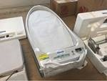
1 | patient heating system | Arizant | Bair Hugger 750 | brand: Arizant; type: Bair Hugger 750; connection: 230 V; | 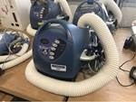
1 | patient warming system | Arizant | Bair Hugger 750 | brand: Arizant; type: Bair Hugger 750; electric connection: 230 V; | 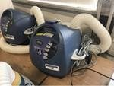

1 | patient warming system | Arizant | Bair Paws 87510 | brand: Arizant; type: Bair Paws 87510; electric connection: 230 V; | 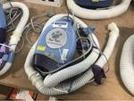
1 | patient warming system | Arizant | Bair Paws 87510 | brand: Arizant; type: Bair Paws 87510; electric connection: 230 V; | 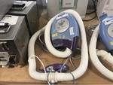
100 | disposable bilicombi | Medela |  | brand: Medela; description: 10 pieces / box; | 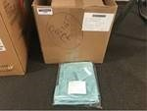
80 | underpads | Medline | USAP3136L C1 | brand: Medline; type:  USAP3136LC1; description: 31x36 ”; | 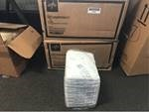
50 | thin wall canisters | Cardinal Health | 65651-530 | brand: Cardinal Health; type: 65651- 530; description: 3000 ml; | 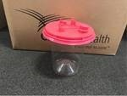
450 | protective seat covers | TotalCare | 3870-NS | brand: TotalCare; type: 3870-  NS; description: 48x56 "; 150 pcs / box; | 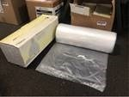
50 | gas sampling lines | Smiths Medical | Portex | brand: Smiths Medical; type: Portex; | 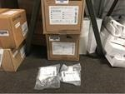

50 | gas sampling lines | Smiths Medical | Portex | brand: Smiths Medical; type: Portex;
100 | gas sampling lines | Smiths Medical | Portex | brand: Smiths Medical; type: Portex;
300 | disposable coasters | Medline | MSC281260 | brand: Medline; type: MSC281260; description: 17x24 "; | 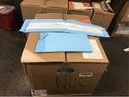
17 | fracture bedpans | Medline |  | brand: Medline; description: yellow; | 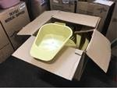
12 | plastic patient utility kit | Medline | DYNC8522 | brand: Medline; type: DYNC8522; description: in box; | 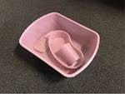
12 | plastic patient set | Medline | DYNC8522 | brand: Medline; type: DYNC8522; description: inbox;
12 | plastic patient utility kit | Medline | DYNC8522 | brand: Medline; type: DYNC8522; description: in box;

1 | hospital bed mattress topper | SkinIQ Arjohuntleig h | Microclimat e Manager | brand: SkinIQ Arjohuntleigh; type: Microclimate Manager; | 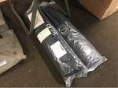
1 | pneumatic anti- shock pants | Vinyl-Tech |  | brand: Vinyl-Tech; description: three bladder; | 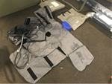
1 | pneumatic anti- shock trouser | Vinyl-Tech |  | brand: Vinyl-Tech; description: three bladder;
1 | smart response clicker system | SMART | PE | brand: SMART; type: PE; description: with (24x) clickers and (1x)  receiver; in bag; | 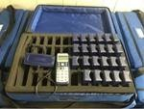
1 | smart response clicker system | SMART | PE | brand: SMART; type: PE; description: with (24x) clickers and (1x)  receiver; in bag;
1 | smart response clicker system | SMART | PE | brand: SMART; type: PE; description: with (24x) clickers and (1x)  receiver; in bag;
1 | subscriber loop analyzer | 3M | Dynatel 965DSP | brand: 3M; type: Dynatel 965DSP; description: with various items in bag; | 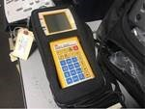

1 | infusion pump controller | Cardinal Health | Alaris 8015 | brand: Cardinal Health; type: Alaris 8015; digital readout:  yes; connection: 230 V; | 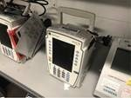
1 | infusion pump controller | Cardinal Health | Alaris 8015 | brand: Cardinal Health; type: Alaris 8015; digital display: yes; electric connection: 230 V; | 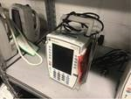
1 | infusion pump controller | Cardinal Health | Alaris 8015 | brand: Cardinal Health; type: Alaris 8015; digital display: yes; electric connection: 230 V; | 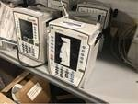
1 | infusion pump controller | Cardinal Health | Alaris 8015 | brand: Cardinal Health; type: Alaris 8015; digital readout:  yes; connection: 230 V; | 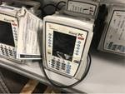
1 | infusion pump controller | Cardinal Health | Alaris 8015 | brand: Cardinal Health; type: Alaris 8015; digital readout:  yes; connection: 230 V; | 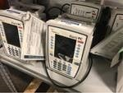
1 | infusion pump controller | Cardinal Health | Alaris 8015 | brand: Cardinal Health; type: Alaris 8015; digital display: yes; electric connection: 230 V;
1 | infusion pump controller | Cardinal Health | Alaris 8015 | brand: Cardinal Health; type: Alaris 8015; digital readout:  yes; connection: 230 V; | 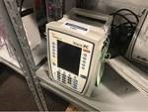

1 | infusion pump module | CareFusion | Alaris PCA 8120 | brand: CareFusion; type: Alaris PCA 8120; digital display: yes; | 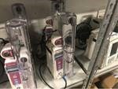
1 | infusion pump module | CareFusion | Alaris PCA 8120 | brand: CareFusion; type: Alaris PCA 8120; digital readout: yes; | 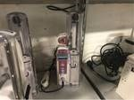
1 | infusion pump module | CareFusion | Alaris PCA 8120 | brand: CareFusion; type: Alaris PCA 8120; digital display: yes; | 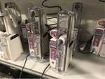
1 | infusion pump module | CareFusion | Alaris PCA 8120 | brand: CareFusion; type: Alaris PCA 8120; digital readout: yes; | 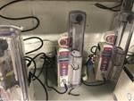
1 | infusion pump module | CareFusion | Alaris PCA 8120 | brand: CareFusion; type: Alaris PCA 8120; digital readout: yes; | 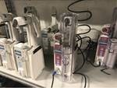
1 | syringe pump module | CareFusion | Alaris 8110 | brand: CareFusion; type: Alaris 8110; digital display: yes; | 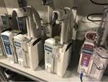
1 | infusion pump module | CareFusion | Alaris 8100 | brand: CareFusion; type: Alaris 8100; digital readout: yes; | 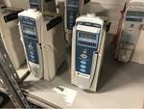

1 | infusion pump module | CareFusion | Alaris 8100 | brand: CareFusion; type: Alaris 8100; digital display: yes; | 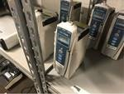
1 | infusion pump module | CareFusion | Alaris 8100 | brand: CareFusion; type: Alaris 8100; digital readout: yes; | 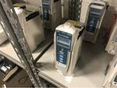
1 | infusion pump module | Cardinal Health | Alaris 8100 | brand: Cardinal Health; type: Alaris 8100; digital display: yes;
1 | infusion pump module | Cardinal Health | Alaris 8100 | brand: Cardinal Health; type: Alaris 8100; digital readout: yes; | 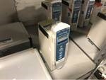
1 | infusion pump module | Cardinal Health | Alaris 8100 | brand: Cardinal Health; type: Alaris 8100; digital display: yes; | 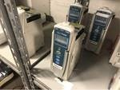
1 | tonometer | Reichert | TONO-PEN XL | brand: Reichert; type: TONO-PEN XL; description: in case; | 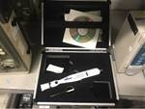
1 | tonometer | Reichert | TONO-PEN XL | brand: Reichert; type: TONO-PEN XL; description: in case that; | 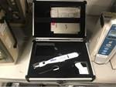

1 | electrosurgical generator | Electricator | 26000 | brand: Electricator; type: 26000; | 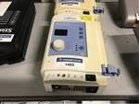
1 | electrosurgical generator | Electricator | 26000 | brand: Electricator; type: 26000; | 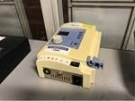
1 | handheld pulse oximeter | Nonin | 2500A | brand: Nonin; type: 2500A; | 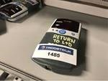
1 | handheld pulse oximeter | Smiths | V3402 | brand: Smiths; type: V3402; | 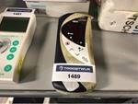
1 | pachymeter | DGH | 55 | brand: DGH; type: 55; description: with calbox; in pocket; | 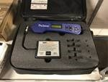
1 | compartmental pressure monitor | MIPM |  | brand: MIPM; | 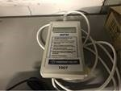
1 | oxygen monitor | MSA | MiniOX 3000 | brand: MSA; type: MiniOX 3000; | 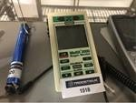

1 | oxygen analyzer | Teledyne |  | brand: Teledyne; | 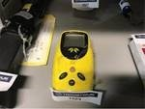
1 | pupillometer | Oasis |  | brand: Oasis; description: in case; | 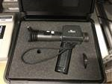
1 | pupillometer | Oasis |  | brand: Oasis; description: in case that;
1 | acupunture stimulator | Pointer Plus |  | brand: Pointer Plus; description: in case; | 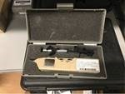
1 | stethoscope | Cooper | Medasonics FP3B | brand: Cooper; type: Medasonics FP3B; description: in bag; | 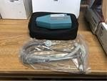
1 | stethoscope | Cooper | Medasonics FP3B | brand: Cooper; type: Medasonics FP3B; description: in bag;
1 | stethoscope | Cooper | Medasonics FP3B | brand: Cooper; type: Medasonics FP3B; description: in bag;

1 | pain control infusion pump | Summit | ambIT PCA | brand: Summit; type: ambIT PCA; | 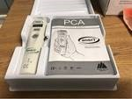
1 | pain relief infusion pump | Summit | ambIT PCA | brand: Summit; type: ambIT PCA;
1 | pain control infusion pump | Summit | ambIT PCA | brand: Summit; type: ambIT PCA;
1 | pain relief infusion pump | Summit | ambIT PCA | brand: Summit; type: ambIT PCA;
7 | power lines |  |  | description: 110V; | 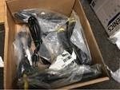
1 | lot of disposable extension sets | Thermal Angel | TA-9EXNTF | brand: Thermal Angel; type: TA- 9EXNTF; | 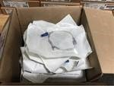
1 | lots of medical clothing |  |  | description: consisting of bathrobes and trousers; | 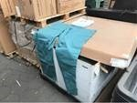

1 | many tampons | Tampax |  | brand: Tampax; description: total approx. 95 boxes; 200 pieces / box; | 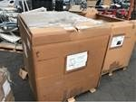
1 | many medical pajamas |  |  | description: Men; size medium; | 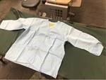
1 | lot of toilet waste kits | Cleanwaste | GO | brand: Cleanwaste; type:  GO; description: in approx. 24 boxes; | 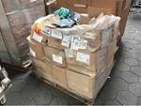
4 | thermotic gastric drainage pump | Gomco | 6003 | brand: Gomco; type: 6003; connection: 110 V; description: inbox; | 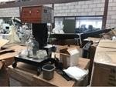
1 | many pajama outfits |  |  | description: Ladies; large size; | 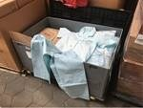
1 | many waste bags | Companion | Biohazard | brand: Medegen; type:  Biohazard; description: total approx. 20 boxes; | 